Compression Post

After the mast was removed from the boat, I noticed that the mast itself was used as negative for the light wiring to the anchor light at the top of the mast and the steaming light as well as the flood lights on the bottom side of the spreaders. We re-wired the mast with two conductor 12 gauge wire to each light fixture. The anchor light was replaced with a tricolor light at the masthead for night sailing. The steaming light was also replaced with a newer fixture. All wiring was deteriorated and the connections at the deck shoe were unusable.

The new mast wiring runs through a hole in the deck in to the inside of the mast compression post, out of it at the bottom and under the floor to the distribution panel at the nav station.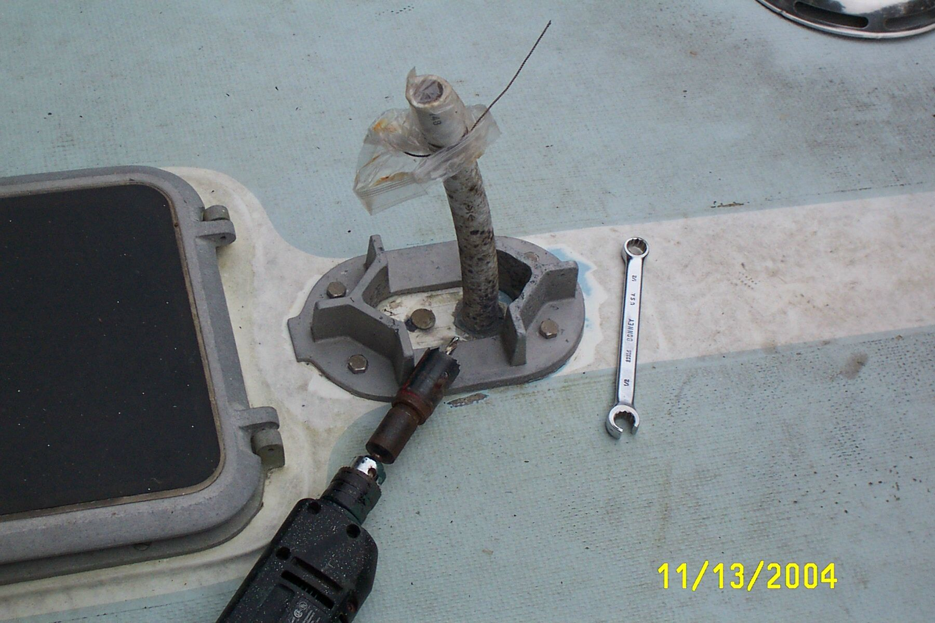

I removed the four lag bolts securing the deck shoe then I cleaned the shoe and found it to be serviceable.

To remove the compression post, I first marked the floor and overhead around the post and removed the six screws holding the post in place. They were hidden by 3/8” teak plugs for cosmetics. To remove the plugs, I screwed a drywall screw into the center of each plug and removed most of the plug. Next, I placed a flat bladed screwdriver parallel to the grain of the plug to twist and remove the rest of the plug. Our post was still in compression, so I used a post jack and a 4x4 post to raise the coach roof just high enough to remove the post. I placed the jack near the shower drain in the head. The largest bulkhead in the boat is slotted into the compression post, so I pulled the post to starboard by a half inch prior to moving it aft and away.

The post is made of four 1x3 teak boards screwed together to form a box. I removed the aft board and inspected the inside of the post. I placed a terminal block inside the post to receive the ends of the mast wiring. It’s easier to wire the terminal block and then install the block into the post.
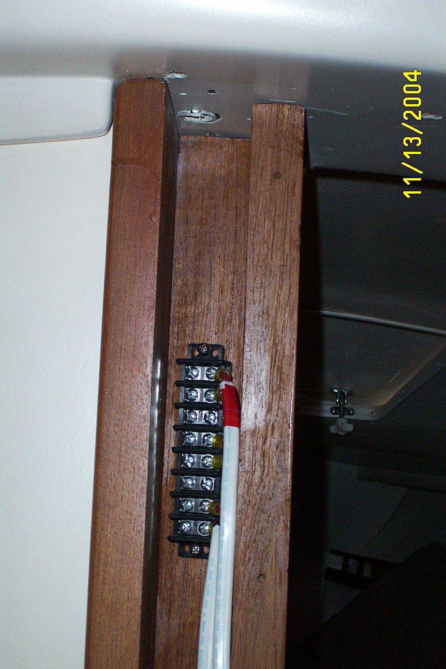
A pilot hole was drilled up through the deck and alignment was checked for a free run of the wiring. Epoxy was used to re-bed the lag bolts for the shoe and a one inch hole was cut to receive a short length of ¾” hose. Note that there is a fore and aft to the shoe; the tab faces aft. The hose was sealed in to the hole. Three sections of 2 x 12 gauge wire will fit through the hose. I gained a healthy respect for the deck at the mast base when I drilled the hole; it was strong and thick.

More holes were drilled at the compression post base to check for rot. Again I found a substantial footing for the mast. I re-filled the holes using a syringe filled with epoxy thickened with 404 High Density Filler from WEST System. The same technique was used in the bilge to check the plywood base of the bilge. The previous owner had screwed the bilge pump into the plywood base and compromised the plywood at the screw holes.
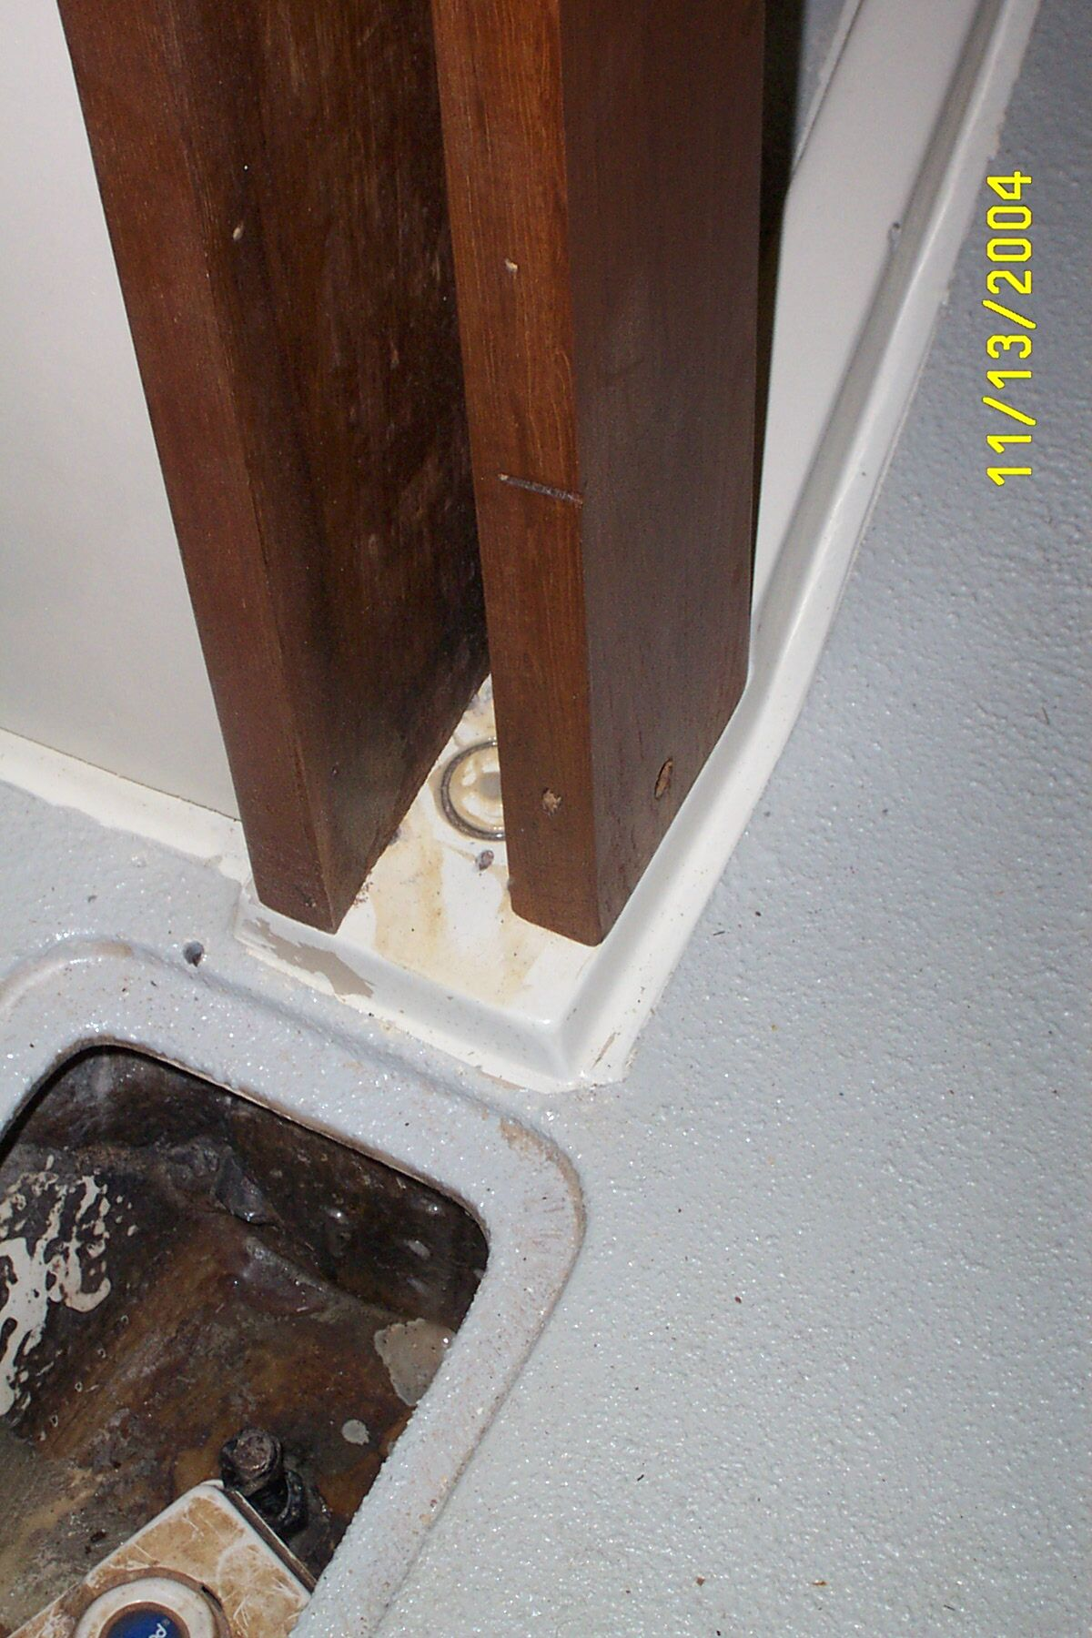

After we replaced three of the four original bulkheads we replaced the mast compression post.

